A NARRATIVE REPORT ON ON-THE-JOB TRAINING
___________________________________________________________
In Partial Fulfilment of the Requirements for the Course

BACHELOR OF SCIENCE IN INFORMATION TECHNOLOGY

Presented by:

- Domingo, Jerome, M.
- Tabora, Rafael, V.

A Report Submitted to the Practicum Coordinator:

MR. EMMAN P. ARIMBUYUTAN, CPA, MBA, MICB

2026
Table of Contents
- Establishment Profile/Company History
Jedlian Holdings Inc. is a multi-industry company that started as a telecommunications-focused organization and later expanded into various business sectors. Over time, it grew its operations to include construction, energy, healthcare, and hospitality services, forming a diversified business group. This expansion was driven by the company’s goal to provide integrated and reliable services across different industries. The organization has built its identity as a holding company managing several subsidiaries under the Jedlian brand.
Today, Jedlian Holdings Inc. operates through its different business units such as Jedlian Communication, Jedlian Construction, Jedlian Energy, Jedlian Drugstore, and Casa Jedliana Hotel and Resort. Each subsidiary focuses on specific services while contributing to the overall growth of the company. The organization continues to develop and expand its presence in various regions, particularly in Luzon. Its history reflects steady growth, diversification, and a commitment to service innovation and customer satisfaction.

- Vision/Mission
  - Vision
Driven by our goal to lead the industry, we aim to provide a complete range of solutions that meet our customers’ requirements.
  - Mission
To provide highly reliable quality work and services while consistently adapting to a fast-paced changing industry.

- Organizational Structure
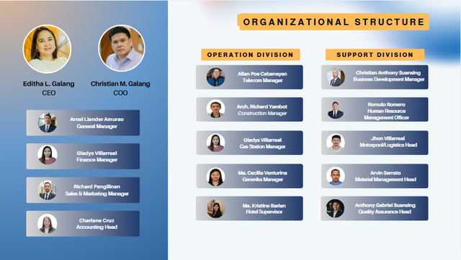

- Facilities and Equipment (with pictures)
Casa Jedliana

Jedlian Communication
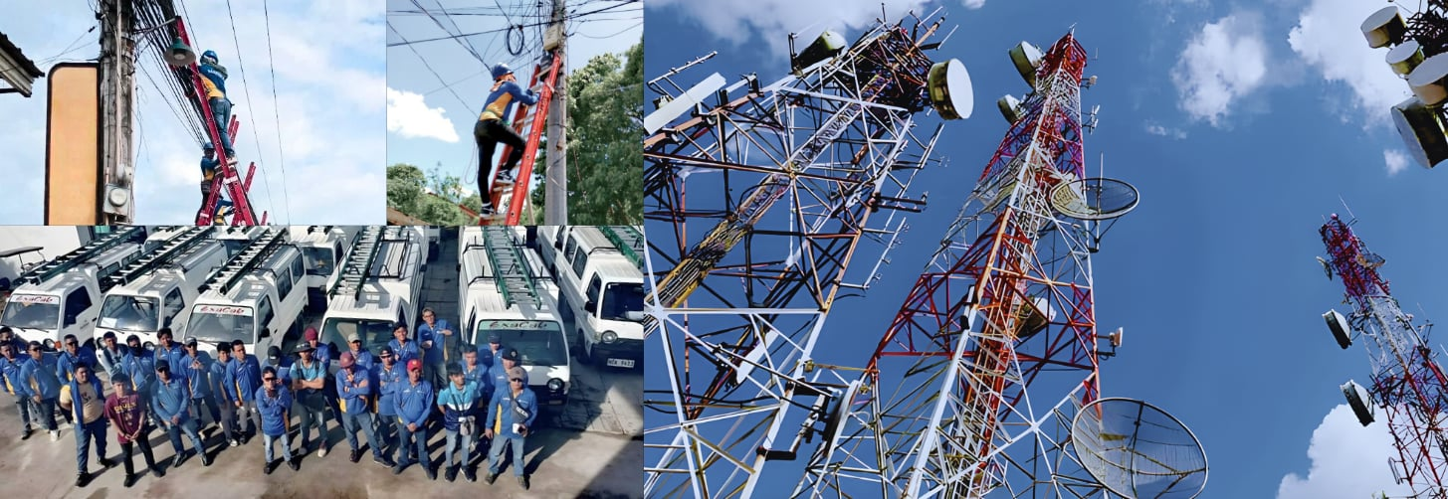
Jedlian Gasoline

Jedlian Drugstore


Jedlian Energy

- Products and Services
Jedlian Holdings Inc. offers a wide range of products and services across multiple industries. These include telecommunications services such as communication and connectivity solutions through Jedlian Communication. The company also provides construction services under Jedlian Construction Inc., supporting infrastructure and development projects. In addition, it operates energy-related services through Jedlian Energy Inc. and fuel stations for gasoline distribution.
The organization also extends its services to healthcare. It manages Jedlian Drugstore, which provides pharmaceutical products and basic health supplies to customers. For hospitality services, Casa Jedliana offers accommodation and resort experiences for guests. Overall, these products and services show the company’s diversified operations aimed at meeting different customer needs.
- Endorsement Letter/MOA
- CV/Resume
Certificate of Completion
- Trainee Evaluation Sheet
- Weekly Work Activities
- Reflection Papers
  - Review of the Organization and its Operations
  - Strengths and Weaknesses of the Organization in Relation to the OJT
  - Strengths and Weaknesses of the Trainee in Relation to the OJT
  - Review of the Training Experience
  - Insights and Lessons Learned During OJT
  - Problems Encountered (and Solutions) During the OJT
  - Summary, Conclusions and Recommendations
- Documentation (Pictures During OJT, Screenshot of Activities, Etc.)



WEEKLY ACCOMPLISHMENT REPORT
To be accomplished following a week’s duty
Name | Jerome M. Domingo | Course/Year | BSIT-4
Department | Information Technology | Month | January

DESCRIPTION OF ACTIVITIES  (Include insights, problems encountered and solution, narration of experiences) | Inclusive  Dates | Number of  Hours

PREPARED BY: Jerome M. Domingo
Trainee’s Signature Over Printed Name

CERTIFIED BY: ___________________________
Signature Over Printed Name

Designation/Position:_______________________________

WEEKLY ACCOMPLISHMENT REPORT
To be accomplished following a week’s duty
Name | Jerome M. Domingo | Course/Year | BSIT-4
Department | Information Technology | Month | February

DESCRIPTION OF ACTIVITIES  (Include insights, problems encountered and solution, narration of experiences) | Inclusive  Dates | Number of  Hours

PREPARED BY: Jerome M. Domingo
Trainee’s Signature Over Printed Name

CERTIFIED BY: ___________________________
Signature Over Printed Name

Designation/Position: ___________________________

WEEKLY ACCOMPLISHMENT REPORT
To be accomplished following a week’s duty
Name | Jerome M. Domingo | Course/Year | BSIT-4
Department | Information Technology | Month | February

DESCRIPTION OF ACTIVITIES  (Include insights, problems encountered and solution, narration of experiences) | Inclusive  Dates | Number of  Hours

PREPARED BY: Jerome M. Domingo
Trainee’s Signature Over Printed Name

CERTIFIED BY: ___________________________
Signature Over Printed Name

Designation/Position: ___________________________

WEEKLY ACCOMPLISHMENT REPORT
To be accomplished following a week’s duty
Name | Jerome M. Domingo | Course/Year | BSIT-4
Department | Information Technology | Month | February

DESCRIPTION OF ACTIVITIES  (Include insights, problems encountered and solution, narration of experiences) | Inclusive  Dates | Number of  Hours

PREPARED BY: Jerome M. Domingo
Trainee’s Signature Over Printed Name

CERTIFIED BY: ___________________________
Signature Over Printed Name

Designation/Position: ___________________________

WEEKLY ACCOMPLISHMENT REPORT
To be accomplished following a week’s duty
Name | Jerome M. Domingo | Course/Year | BSIT-4
Department | Information Technology | Month | March

DESCRIPTION OF ACTIVITIES  (Include insights, problems encountered and solution, narration of experiences) | Inclusive  Dates | Number of  Hours

PREPARED BY: Jerome M. Domingo
Trainee’s Signature Over Printed Name

CERTIFIED BY: ___________________________
Signature Over Printed Name

Designation/Position: ___________________________

WEEKLY ACCOMPLISHMENT REPORT
To be accomplished following a week’s duty
Name | Jerome M. Domingo | Course/Year | BSIT-4
Department | Information Technology | Month | March

DESCRIPTION OF ACTIVITIES  (Include insights, problems encountered and solution, narration of experiences) | Inclusive  Dates | Number of  Hours

PREPARED BY: Jerome M. Domingo
Trainee’s Signature Over Printed Name

CERTIFIED BY: ___________________________
Signature Over Printed Name

Designation/Position: ___________________________

WEEKLY ACCOMPLISHMENT REPORT
To be accomplished following a week’s duty
Name | Jerome M. Domingo | Course/Year | BSIT-4
Department | Information Technology | Month | March

DESCRIPTION OF ACTIVITIES  (Include insights, problems encountered and solution, narration of experiences) | Inclusive  Dates | Number of  Hours

PREPARED BY: Jerome M. Domingo
Trainee’s Signature Over Printed Name

CERTIFIED BY: ___________________________
Signature Over Printed Name

Designation/Position: ___________________________

WEEKLY ACCOMPLISHMENT REPORT
To be accomplished following a week’s duty
Name | Jerome M. Domingo | Course/Year | BSIT-4
Department | Information Technology | Month | March

DESCRIPTION OF ACTIVITIES  (Include insights, problems encountered and solution, narration of experiences) | Inclusive  Dates | Number of  Hours

PREPARED BY: Jerome M. Domingo
Trainee’s Signature Over Printed Name

CERTIFIED BY: ___________________________
Signature Over Printed Name

Designation/Position: ___________________________

WEEKLY ACCOMPLISHMENT REPORT
To be accomplished following a week’s duty
Name | Jerome M. Domingo | Course/Year | BSIT-4
Department | Information Technology | Month | April

DESCRIPTION OF ACTIVITIES  (Include insights, problems encountered and solution, narration of experiences) | Inclusive  Dates | Number of  Hours

PREPARED BY: Jerome M. Domingo
Trainee’s Signature Over Printed Name

CERTIFIED BY: ___________________________
Signature Over Printed Name

Designation/Position: ___________________________

WEEKLY ACCOMPLISHMENT REPORT
To be accomplished following a week’s duty
Name | Jerome M. Domingo | Course/Year | BSIT-4
Department | Information Technology | Month | April

DESCRIPTION OF ACTIVITIES  (Include insights, problems encountered and solution, narration of experiences) | Inclusive  Dates | Number of  Hours

PREPARED BY: Jerome M. Domingo
Trainee’s Signature Over Printed Name

CERTIFIED BY: ___________________________
Signature Over Printed Name

Designation/Position: ___________________________

WEEKLY ACCOMPLISHMENT REPORT
To be accomplished following a week’s duty
Name | Jerome M. Domingo | Course/Year | BSIT-4
Department | Information Technology | Month | April

DESCRIPTION OF ACTIVITIES  (Include insights, problems encountered and solution, narration of experiences) | Inclusive  Dates | Number of  Hours

PREPARED BY: Jerome M. Domingo
Trainee’s Signature Over Printed Name

CERTIFIED BY: ___________________________
Signature Over Printed Name

Designation/Position: ___________________________

WEEKLY ACCOMPLISHMENT REPORT
To be accomplished following a week’s duty
Name | Jerome M. Domingo | Course/Year | BSIT-4
Department | Information Technology | Month | April

DESCRIPTION OF ACTIVITIES  (Include insights, problems encountered and solution, narration of experiences) | Inclusive  Dates | Number of  Hours

PREPARED BY: Jerome M. Domingo
Trainee’s Signature Over Printed Name

CERTIFIED BY: ___________________________
Signature Over Printed Name

Designation/Position: ___________________________

Review of the Organization and its Operations
To be accomplished after the Completion of the OJT
Name | Jerome M. Domingo | Course/Year | BSIT-4
Department | Information Technology | Month | April

Jedlian Holdings Inc. is a diversified company operating across multiple industries, including telecommunications, construction, energy (gasoline stations), healthcare (drugstores), and hospitality (hotel and resort services). It serves as the parent company of several business units such as Jedlian Communication, Jedlian Construction, Jedlian Gasoline, Jedlian Drugstore, and Casa Jedliana Hotel and Resort.
The organization’s operations focus on delivering reliable, quality services while adapting to technological advancements and customer needs. Its mission emphasizes innovation, customer satisfaction, and continuous improvement, while its vision aims to become a leading provider of complete service solutions.
Operationally, the company has established a presence across various regions in Luzon, managing multiple outlets, infrastructure (such as cell sites and DSL cabinets), and service operations.

PREPARED BY: Jerome M. Domingo
Trainee’s Signature Over Printed Name

Strengths and Weaknesses of the Organization in Relation
to OJT
To be accomplished after the Completion of the OJT
Name | Jerome M. Domingo | Course/Year | BSIT-4
Department | Information Technology | Month | April

Strength
• Diversified business operations (telecommunications, construction, energy, healthcare, hospitality)
• Multiple revenue streams reduce financial risk
• Strong focus on innovation and adapting to new technologies
• Customer-centered service approach
• Continuous business expansion and growth strategy
• Ability to operate across different regions
• Experience in handling large-scale and multi-sector operations

Weaknesses
- The organization may experience challenges in maintaining consistent operational standards across its diverse business units.
- Monitoring and controlling performance across various sectors can be challenging, affecting overall efficiency and accountability.
- The need to comply with different industry regulations increases administrative and operational demands.

PREPARED BY: ___________________________
Trainee’s Signature Over Printed Name

Strengths and Weaknesses of the Individual in Relation to OJT
To be accomplished after the Completion of the OJT
Name | Jerome M. Domingo | Course/Year | BSIT-4
Department | Information Technology | Month | April

Strength
- Fast learner; able to quickly understand tasks and apply instructions effectively
- Adaptable to new environments, systems, and work conditions
- Willingness to learn and improve through feedback and experience
- Can work independently with minimal supervision when tasks are understood
- Able to follow instructions and procedures accurately
- Cooperative and able to work with team members when needed
Weaknesses
- Tendency to become lazy or lose motivation at times
- Does not consistently communicate updates or ask questions when needed
- Hesitates to seek help, which may delay task completion
- Time management skills need improvement, especially under pressure

PREPARED BY: ___________________________
Trainee’s Signature Over Printed Name

Review of the Training Experience
To be accomplished after the Completion of the OJT
Name | Jerome M. Domingo | Course/Year | BSIT-4
Department | Information Technology | Month | April

During my On-the-Job Training (OJT), I gained valuable experience that helped me improve my technical skills and understanding of real-world development work. I was able to learn and use the Laravel framework, which introduced me to how web applications are built, structured, and maintained in a professional environment. I also became familiar with different tools and software used alongside Laravel, which helped me better understand development workflows and system processes. This experience allowed me to apply the knowledge I learned in school to actual tasks and real project scenarios.

PREPARED BY: ___________________________
Trainee’s Signature Over Printed Name

Insights and Lessons Learned During OJT
To be accomplished after the Completion of the OJT
Name | Jerome M. Domingo | Course/Year | BSIT-4
Department | Information Technology | Month | April

Throughout my training, I learned the importance of problem-solving, adaptability, and continuous learning in a workplace setting. I encountered challenges such as debugging errors and working with unfamiliar code, which helped improve my critical thinking and analytical skills. I also realized the importance of discipline, responsibility, and time management in completing tasks efficiently. In addition, I learned that communication and teamwork are essential in ensuring smooth workflow and better results. Overall, my OJT experience helped me grow not only in technical skills but also in work attitude and professional development.

PREPARED BY: ___________________________
Trainee’s Signature Over Printed Name

Problems Encountered (and Solutions) During OJT
To be accomplished after the Completion of the OJT
Name | Jerome M. Domingo | Course/Year | BSIT-4
Department | Information Technology | Month | April

During my On-the-Job Training (OJT), I encountered several issues while developing a Point of Sale (POS) system. I experienced bugs during transaction processing, data saving, and system validation. I also had difficulties in creating an inventory tracking system for ingredients, especially in updating stock accurately. In addition, generating reports for gains, losses, and COGS was challenging due to complex data calculations.
To solve these problems, I used debugging techniques such as checking logs and testing each feature step by step. I also reviewed my code carefully to identify errors and improve system logic. When needed, I asked guidance from supervisors and referred to Laravel documentation for better understanding. Through continuous testing and improvement, I was able to fix errors and enhance the system’s accuracy and performance.

PREPARED BY: ___________________________
Trainee’s Signature Over Printed Name

Summary, Conclusions and Recommendations
To be accomplished after the Completion of the OJT
Name | Jerome M. Domingo | Course/Year
Department | Information Technology | Month

During my On-the-Job Training (OJT), I was given the opportunity to apply my knowledge in real-world development tasks, particularly in using the Laravel framework. I was involved in developing systems such as a Point of Sale (POS), inventory tracking for ingredients, and reporting features for business performance. Throughout the training, I encountered technical challenges such as bugs, system errors, and difficulties in data handling, which helped me improve my problem-solving and debugging skills. Overall, the experience provided meaningful exposure to actual software development processes in a professional environment.
In conclusion, my OJT experience was highly beneficial in enhancing both my technical and personal skills. It helped me understand how real systems are built, maintained, and improved while working under real workplace conditions. I also learned the importance of patience, attention to detail, and continuous learning when dealing with complex tasks. The challenges I faced contributed significantly to my growth as a developing programmer.
It is recommended that future trainees continue practicing hands-on coding and familiarize themselves with Laravel and related tools before and during their OJT. Companies may also consider providing more structured guidance and documentation to help interns adapt more quickly to project requirements. Additionally, improving communication between interns and supervisors can help resolve issues more efficiently. Overall, continuous learning and active participation are key to maximizing the OJT experience.

PREPARED BY: ___________________________
Trainee’s Signature Over Printed Name

Documentation
To be accomplished after the Completion of the OJT
Name | Jerome M. Domingo | Course/Year | BSIT-4
Department | Information Technology | Month | April

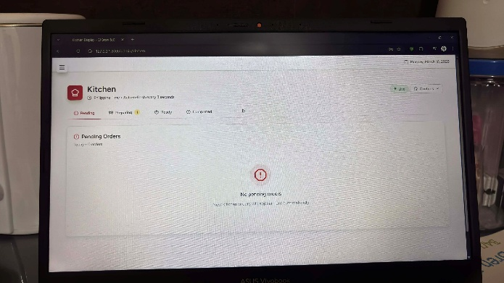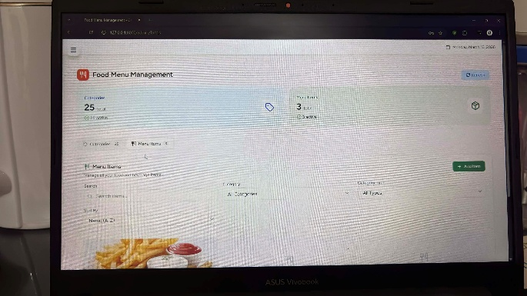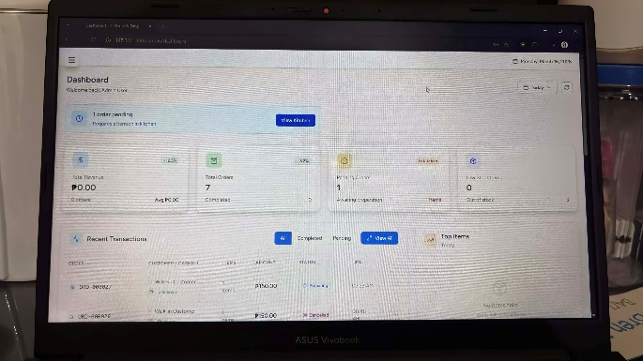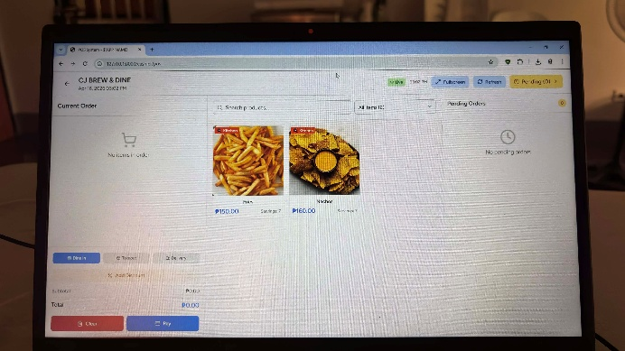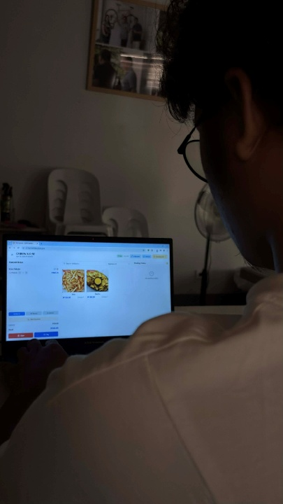

PREPARED BY: ___________________________
Trainee’s Signature Over Printed Name

Daily Time Record
Provide a pouch for the daily time record. Make sure your attendance/time-in and out are signed by your superior or manager
Name | Jerome M. Domingo | Course/Year | BSIT-4
Department | Information Technology | Month | April

PREPARED BY: ___________________________
Trainee’s Signature Over Printed Name

